AIT 632 – Database Management Systems

D3 Physical Database Design

Team SSR

The Entity Relationship Diagram is as shown below:

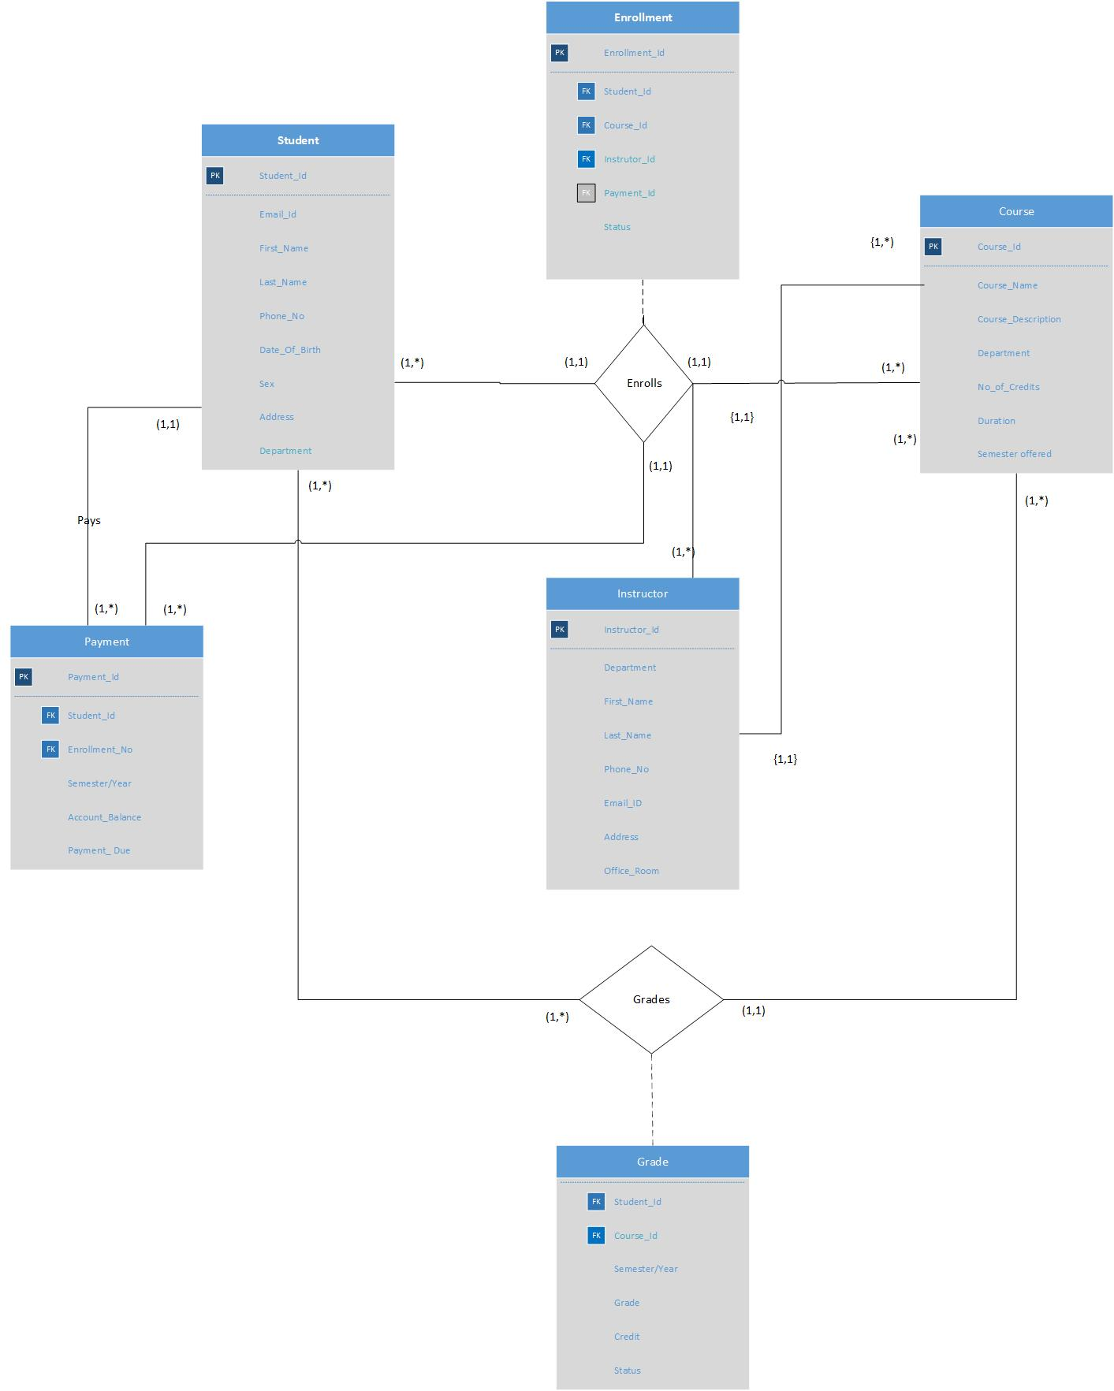

In the Entity Relationship diagram, we have a many to many relationship between student and course. Hence there would be 3 tables and they are student, course and grade. The grade table would have two primary keys course_ID, and Student_ID. Student_ID and course_ID are foreign keys since they reference to the primary keys of other tables.

There exists a quaternary relationship between student, course, instructor and payment. The relationship enroll has a primary key Enrollment_ID and Student_ID, Course_ID, Instructor_ID Payment_ID are foreign keys since they reference primary keys of other tables.

The relationship between student and payment is a one to many relationship. Hence the primary key from the one side (student) migrates as a foreign key to the many side (payment).

The relationship between instructor and enrollment is a one to many relationship. Hence the primary key from the one side the (instructor) migrates as a foreign key to the many side (enrollment).

The tables are as follows:

For the quaternary relationship between student, course and instructor.

Student (Student_ID {PK}, Email_ID, First_name, Last_name, Phone_No, Address, Date of birth, Gender, Department)

|  |  |  |  |
| --- | --- | --- | --- |
| Attributes | DataType | constraint | null/notnull |
| Student_ID | int | Primary key | Not null |
| Email_ID | Varchar(30) |  | NotNull |
| First_name | Varchar(20) |  | NotNull |
| Last_name | Varchar(20) |  | NotNull |
| Phone_No | Varchar(30) |  | NotNull |
| Address | Varchar(100) |  | NotNull |
| Date of birth | Date |  | NotNull |
| Gender | Varchar(6) |  | NotNull |

Course (Course_ID {PK}, Course_Name, No of credits, Duration, Semester offered, Class_room, Department)

|  |  |  |  |
| --- | --- | --- | --- |
| Attributes | DataType | constraint | Null/not null |
| Course_ID | int | Primary key | NotNull |
| Course_Name | Varchar(20) |  | NotNull |
| No of credits | Number |  | NotNull |
| Duration | varchar(20) |  | NotNull |
| Semester offered | varchar(20) |  | NotNull |
| Class_room | varchar(20) |  | NotNull |
| Department | varchar(30) |  | NotNull |

Instructor(Instructor_ID{PK}, First_name, Last_name , Phone_No, Email_ID, Office_room, Department)

|  |  |  |  |
| --- | --- | --- | --- |
| Attributes | DataType | constraint | Null/not null |
| Instructor_ID | int | Primary key | Not null |
| First_name | varchar(20) |  | Not null |
| Last_name | varchar(20) |  | Not null |
| Phone_No | varchar(20) |  | Not null |
| Email_ID | varchar(20) |  | Not null |
| Office_room | varchar(5) |  | Not null |
| Department | varchar(20) |  | Not null |

Payment (Payment_ID{PK}, Student_ID{FK}, Enrollment_ID {FK}, Sem/Year Account balance, Payment_due).

|  |  |  |  |
| --- | --- | --- | --- |
| Attributes | DataType | constraint | Null/not null |
| Payment_ID | int | primary key | not null |
| Student_ID | int | foreign key | not null |
| Enrollment_ID | int | foreign key | not null |
| Account balance | numeric(12,2) |  | Not null |
| Payment_due | numeric(12,2) |  | Not null |
| Sem_year | Varchar(20) |  | Not null |

Enrollment (Enrollment{PK}, Student_ID{FK}, Course_ID{FK}, Payment_ID{FK}, Instructor_ID{FK}, Payment_ID{FK}, status)

|  |  |  |  |
| --- | --- | --- | --- |
| Attributes | DataType | constraint | Null/not null |
| Enrollment_ID | int | Primary key | not null |
| Student_ID | int | Foreign key | not null |
| Course_ID | int | Foreign key | not null |
| Payment_ID | int | Foreign key | null |
| Instructor_ID | int | Foreign key | not null |
| status | varchar(20) |  | not null |

For the grade table:

|  |  |  |  |
| --- | --- | --- | --- |
| Attributes | DataType | constraint | Null/not null |
| Student_ID | int | Foreign key | not null |
| Sem/year | varchar(20) |  | not null |
| Course_ID | Int | Foreign key | not null |
| Grade | varchar(2) |  | not null |
| Credit | int |  | not null |
| status | varchar(20) |  | not null |

The relational model is as shown below

|  |  |  |  |  |  |
| --- | --- | --- | --- | --- | --- |
| Payment_ID | Student_ID | Enrollment_ID | Semester/Year | Account balance | Payment_due |

|  |  |  |  |  |  |  |  |  |
| --- | --- | --- | --- | --- | --- | --- | --- | --- |
| Student_ID | Email_ID | First_  name | Last_  name | Phone_  No | Address | Date Of  Birth | Gender | Department |

|  |  |  |  |  |  |
| --- | --- | --- | --- | --- | --- |
| Enrollment_ID | Student_ID | Course_ID | Instructor_ID | Payment_ID | Status |

|  |  |  |  |  |  |  |
| --- | --- | --- | --- | --- | --- | --- |
| Instructor_ID | Email_ID | First_  name | Last_  name | Phone_  No | Office_room | Department |

|  |  |  |  |  |  |  |
| --- | --- | --- | --- | --- | --- | --- |
| Course_ID | Course_  Name | No of Credits | Duration | Semester  Offered | Class_room | Department |

For the many to many relationship between student and course the tables are:

Student (Student_ID {PK}, Email_ID, First_name, Last_name, Phone_No, Address, Date of birth, Gender, Department

Course (Course_ID {PK}, Course_Name, No of credits, Duration, Semester offered, Class_room, Department)

Grade (Student_ID{FK}, Course_ID{FK},Sem/Year, grade, credit, status)

|  |  |  |  |  |  |  |  |  |
| --- | --- | --- | --- | --- | --- | --- | --- | --- |
| Student_ID | Email_ID | First_  name | Last_  name | Phone_  No | Address | Date Of  Birth | Gender | Department |

|  |  |  |  |  |  |
| --- | --- | --- | --- | --- | --- |
| Course_ID | Student_ID | Semester/Year | Grade | Credit | Status |

|  |  |  |  |  |  |  |
| --- | --- | --- | --- | --- | --- | --- |
| Course_ID | Course_  Name | No of Credits | Duration | Semester  Offered | Class_room | Department |

For the one to many relationship between student and payment, the student pays for the courses he has enrolled. Hence the enrollment has to be included as a table since payment cannot be found without enrollment ID.

Student (Student_ID {PK}, Email_ID, First_name, Last_name, Phone_No, Address, Date of birth, Gender, Department )

Payment (Payment_ID{PK}, Student_ID{FK}, Enrollment_ID {FK}, Account balance, Payment_due)

Enrollment (Enrollment{PK}, Student_ID{FK}, Course_ID{FK},Instructor_ID{FK}, status)

|  |  |  |  |  |  |  |  |  |
| --- | --- | --- | --- | --- | --- | --- | --- | --- |
| Student_ID | Email_ID | First_  name | Last_  name | Phone_  No | Address | Date Of  Birth | Gender | Department |

|  |  |  |  |  |  |
| --- | --- | --- | --- | --- | --- |
| Payment_ID | Student_ID | Enrollment_ID | Semester/Year | Account balance | Payment_due |

|  |  |  |  |  |  |
| --- | --- | --- | --- | --- | --- |
| Enrollment_ID | Student_ID | Course_ID | Instructor_ID | Payment_ID | Status |

|  |  |  |  |  |  |  |
| --- | --- | --- | --- | --- | --- | --- |
| Course_ID | Course_  Name | No of Credits | Duration | Semester  Offered | Class_room | Department |

|  |  |  |  |  |  |  |
| --- | --- | --- | --- | --- | --- | --- |
| Instructor_ID | Email_ID | First_  name | Last_  name | Phone_  No | Office_room | Department |

The last two tables are present to show the referential integrity constraint.

**Business Rules:**

1. There exists a quaternary relationship between student, course, instructor and payment.
2. Many students enroll in many courses. Hence the relationship between student and courses is many to many relationship.
3. Many students can get grades for many courses that they have enrolled for.
4. One student can make payment for one or more courses. Hence the relationship between student and payment is a one to many relationship.
5. Many Instructors can teach many courses. Hence the relationship between instructor and courses is also a many to many relationship.
6. One instructor can enroll to teach many courses.
7. Many payments can be made for multiple enrollments.

**Functional Dependencies:**

Student_ID Email_ID, First_name, Last_name, Phone_No, Address, Date of birth, Gender, Department

Course_ID Course_Name, Course_Description, No_of_credits, Duration, Semester_offered, Class_room

Instructor_ID First_name, Last_name , Phone_No, Email_ID, Office_room, Address, Department

Payment_ID Account balance, Payment_due, semester/year.

Enrollment_ID Status

**INTEGRITY CONSTRAINTS**

**Entity Integrity**

* Student_ID in Student table cannot be NULL.
* Course_ID in Course table cannot be NULL.
* Instructor_ID in Instructor table cannot be NULL.
* Enrollment_ID in enrollment table cannot be NULL.
* Payment_ID in Payment table cannot be NULL.
* Grade in the Grade table can only be two characters.

Domain constraints

For Student table

|  |  |  |  |
| --- | --- | --- | --- |
| Attributes | Domain Name | Meaning | Domain Definition |
| Student_ID | Student identification | Set of all possible student id’s | Integer size = 7, range =0000000 to 9999999 |
| Email_ID | Student’s Email ID | Set of all possible student’s email ID’s | Character size=30 |
| First_name | Student’s First name | Set of all possible student’s first names | Character size =20 |
| Last_name | Student’s Last name | Set of all possible student’s last names | Character size =20 |
| Phone_No | Student’s Phone Number | Set of all possible student phone Numbers | Character size =30  Range =000-000-0000  To 999-999-9999 |
| Address | Student’s Address | Set of all possible student’s addresses | Character size = 100 |
| Date of birth | Student’s Date of Birth | Set of all possible student’s date of births | Date format -mm/dd/yyyy |
| Gender | Student’s gender | Set of all possible student’s gender | Character size from 1 to 6 |
| Department | Student’s Department | Set of all possible student’s department | Character size = 20 |

For Course table:

|  |  |  |  |
| --- | --- | --- | --- |
| Attributes | Domain Name | Meaning | Domain Definition |
| Course_ID | Course identification | Set of all possible course id’s | Integer size = 7, range =0000000 to 9999999 |
| Course_Name | Courses Names | Set of all possible course names | Character size=20 |
| No_of_credits | Number of credits | Set of all possible course credits | Number (5,2)  Example (3.00) |
| Duration | Course duration | Set of all course’s duration | Character size = 20 |
| Semester_offered | Semester during which course offered | Set of all courses offered during each semester | Character size = 20 |
| Class_room | Classroom where each course | Set of all possible course classrooms | Character size = 20 |
| Department | Department’s | Set of all possible department’s courses | Character size = 30 |

For instructor table

|  |  |  |  |
| --- | --- | --- | --- |
| Attributes | Domain Name | Meaning | Domain Definition |
| Instructor_ID | Student identification | Set of all possible Instructor ID’s | Integer size = 7, range =0000000 to 9999999 |
| First_name | Instructor’s First name | Set of all possible Instructor’s first names | Character size =20 |
| Last_name | Instructor’s Last name | Set of all possible Instructor’s last names | Character size =20 |
| Phone_No | Instructor’s Phone Number | Set of all possible Instructors phone Numbers | Character size =20 |
| Address | Instructor’s Address | Set of all possible Instructor’s addresses | Character size = 100 |
| Email_ID | Instructor’s Email_ID | Set of all possible Instructor’s Email ID | Character size =20 |
| Office_room | Instructor’s Office_room | Set of all possible Instructor’s Office_rooms | Character size from 1 to 5 |
| Department | Instructor’s Department | Set of all possible Instructor’s departments | Character size = 20 |

For payment table:

|  |  |  |  |
| --- | --- | --- | --- |
| Attributes | Domain Name | Meaning | Domain Definition |
| Payment_ID | Payment identification | Set of all possible payment id’s | Integer size = 7, range =0000000 to 9999999 |
| Student_ID | Student identification | Set of all possible student ID’s | Integer size = 7, range =0000000 to 9999999 |
| Enrollment_ID | Enrollment identification | Set of all possible student’s enrolled courses | Integer size = 7, range =0000000 to 9999999 |
| Sem/Year | Semester and year | Semester and year each course is enrolled | Character size =20 |
| Account_Balance | Student’s account balance | Balance that is to be paid by the student is reflected by this attribute | Number size =(12,2)  For example (000000.00) |
| Payment due | Student’s Payment due | If there is any amount due, they should pay the amount within the due date. | Number size =(12,2)  For example (000000.00) |

For enrollment table

|  |  |  |  |
| --- | --- | --- | --- |
| Attributes | Domain Name | Meaning | Domain Definition |
| Enrollment_ID | Enrollment identification | Set of all possible student enrollment ID’s | Integer size = 7, range =0000000 to 9999999 |
| Student_ID | Student identification | Set of all possible student id’s | Integer size = 7, range =0000000 to 9999999 |
| Instructor_ID | Student identification | Set of all possible Instructor ID’s | Integer size = 7, range =0000000 to 9999999 |
| Payment_ID | Payment identification | Set of all possible payment id’s | Integer size = 7, range =0000000 to 9999999 |
| Course_ID | Course identification | Set of all possible course id’s | Integer size = 7, range =0000000 to 9999999 |
| Status | Enrollment status | Shows whether the instructor or student has enrolled for a subject or not | Character Size = 20 |

For Grade table:

|  |  |  |  |
| --- | --- | --- | --- |
| Attributes | Domain Name | Meaning | Domain Definition |
| Student_ID | Student identification | Set of all possible student id’s | Integer size = 7, range =0000000 to 9999999 |
| Course_ID | Course identification | Set of all possible course id’s | Integer size = 7, range =0000000 to 9999999 |
| Sem/Year | Semester and Year | Semester and year the student or instructor has enrolled. | Character size = 20  Example could be Fall2018 |
| Grade | Grade | Grades obtained by the student | Character size = 2  Example (A-) |
| Credit | Course credits | Credits of each course | Number (5,2) |
| Status | Status | Status indicates whether the student has passed, failed or withdrawn a subject | Character size =20 |

Student table:

Create query:

CREATE TABLE STUDENT

(

student_ID int NOT NULL,

Email_ID varchar(30) NOT NULL,

First_Name varchar(20) NOT NULL,

Last_Name varchar(20) NOT NULL,

Phone_NO varchar(30) NOT NULL,

Address varchar(100) NOT NULL,

Date_of_Birth date NOT NULL,

Gender varchar(6) NOT NULL,

CONSTRAINT STUDENT_pk PRIMARY KEY(student_ID)

);

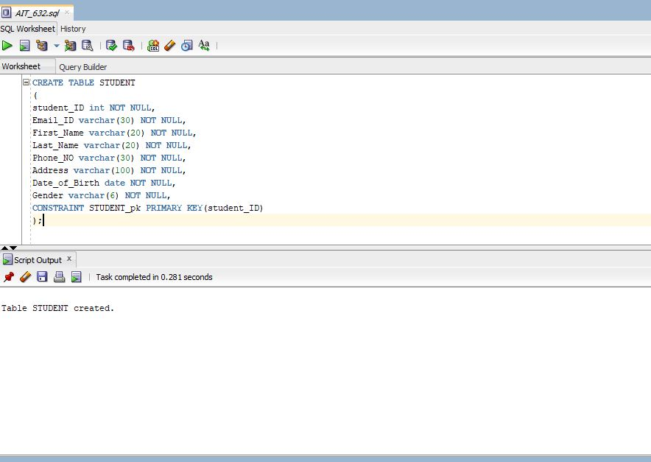

Insert query:

INSERT INTO STUDENT

(Student_ID,Email_ID,First_Name,Last_Name,Phone_No,Address,Date_of_Birth,Gender) values('680234','rkachi1@students.towson.edu','Raj','kk','443-901-9595','6729 Airlie Way Baltimore','30-JUNE-1995','Male');

INSERT INTO STUDENT

(Student_ID,Email_ID,First_Name,Last_Name,Phone_No,Address,Date_of_Birth,Gender) values('680132','sgobu2@students.towson.edu','Saranya','Gobu','443-231-1776','950 walnut wood road Baltimore','26-MAY-1995','Female');

INSERT INTO STUDENT

(Student_ID,Email_ID,First_Name,Last_Name,Phone_No,Address,Date_of_Birth,Gender) values('680232','spokre1@students.towson.edu','Sreya','Pokhrel','443-901-1227','7021 Bloom Road Baltimore','19-JAN-1992','Female');

INSERT INTO STUDENT

(Student_ID,Email_ID,First_Name,Last_Name,Phone_No,Address,Date_of_Birth,Gender) values('680453','adi1@students.towson.edu','Aditya','Shekar','443-991-9595','6729 Donachie Road Baltimore','01-DEC-1992','Male');

INSERT INTO STUDENT

(Student_ID,Email_ID,First_Name,Last_Name,Phone_No,Address,Date_of_Birth,Gender) values('680122','deepika1@students.towson.edu','Deepika','patel','443-901-9595','7021 Cokesville Road Baltimore','02-MARCH-1995','female');

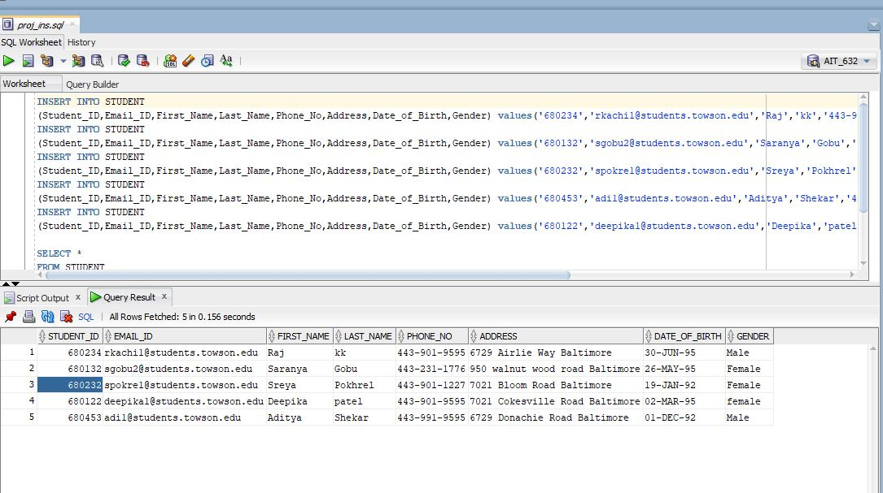

COURSE table

Create query:

CREATE TABLE COURSE

(

Course_ID int NOT NULL,

Course_name varchar(20) NOT NULL,

No_of_credits numeric(38) NOT NULL,

Duration varchar(20) NOT NULL,

Semester_Offered varchar(20) NOT NULL,

Class_room varchar(20) NOT NULL,

Department varchar(30) NOT NULL,

CONSTRAINT COURSE_pk PRIMARY KEY(Course_ID)

);

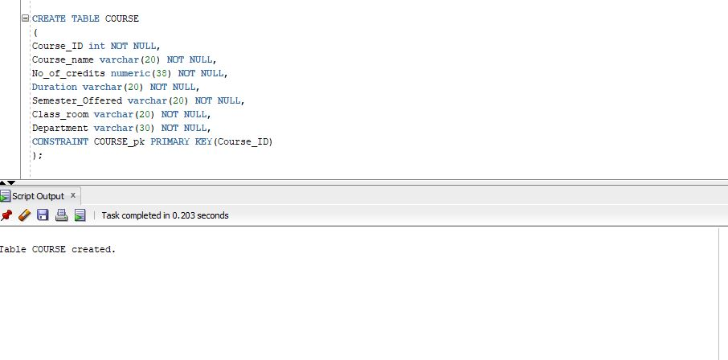

Insert query:

INSERT INTO COURSE

(Course_ID,Course_Name,No_of_credits,duration,semester_offered,class_room,department) values('632','DBMS','3','6 months','Fall 2018','ES102','AIT');

INSERT INTO COURSE

(Course_ID,Course_Name,No_of_credits,duration,semester_offered,class_room,department) values('624','Softengfund','3','6 months','Spring 2018','YR104','AIT');

INSERT INTO COURSE

(Course_ID,Course_Name,No_of_credits,duration,semester_offered,class_room,department) values('732','Advanced DBMS','3','6 months','Spring 2019','ES103','AIT');

INSERT INTO COURSE

(Course_ID,Course_Name,No_of_credits,duration,semester_offered,class_room,department) values('612','Risk Analysis','3','6 months','Summer 2019','LI01','AIT');

INSERT INTO COURSE

(Course_ID,Course_Name,No_of_credits,duration,semester_offered,class_room,department) values('614','Software security','3','6 months','Spring 2018','YR122','AIT');

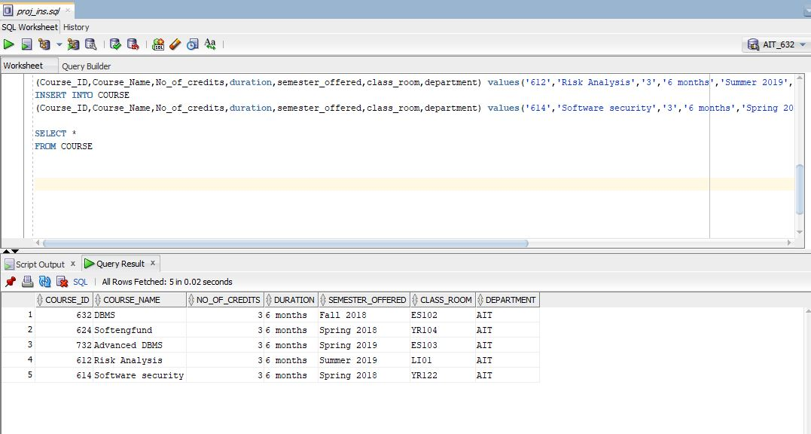

Instructor table

Create query:

CREATE TABLE INSTRUCTOR

(

Instructor_ID int NOT NULL,

First_name varchar(20) NOT NULL,

Last_name varchar(20) NOT NULL,

Phone_no varchar(20) NOT NULL,

Email_ID varchar(20) NOT NULL,

Office_room varchar(5) NOT NULL,

Department varchar(20) NOT NULL,

CONSTRAINT INSTRUCTOR_pk PRIMARY KEY(Instructor_ID)

);

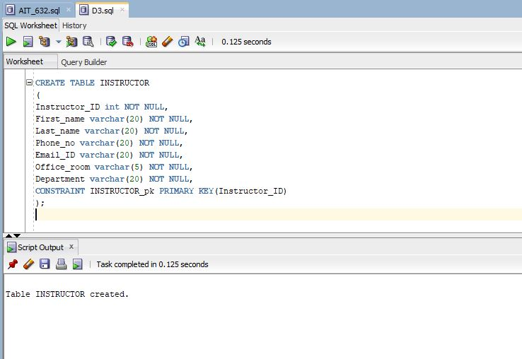

Insert Query:

INSERT INTO INSTRUCTOR

(Instructor_ID,First_Name,Last_Name,Phone_No,Email_ID,Office_room,department)values('4012','Jinie','Pak','443-301-8989','jpak1@towson.edu','YR401','CIS');

INSERT INTO INSTRUCTOR

(Instructor_ID,First_Name,Last_Name,Phone_No,Email_ID,Office_room,department)values('4011','Cheryl','Brown','443-121-8989','cbrown1@towson.edu','YR444','CIS');

INSERT INTO INSTRUCTOR

(Instructor_ID,First_Name,Last_Name,Phone_No,Email_ID,Office_room,department)values('4124','Jeff','Tirschman','443-782-8989','jeff1@towson.edu','YR121','AIT');

INSERT INTO INSTRUCTOR

(Instructor_ID,First_Name,Last_Name,Phone_No,Email_ID,Office_room,department)values('4123','Jal','Irani','443-221-8989','jal1@towson.edu','YR401','CIS');

INSERT INTO INSTRUCTOR

(Instructor_ID,First_Name,Last_Name,Phone_No,Email_ID,Office_room,department)values('4125','Harry','Saasho','442-301-7928','harry1@towson.edu','YR102','AIT');

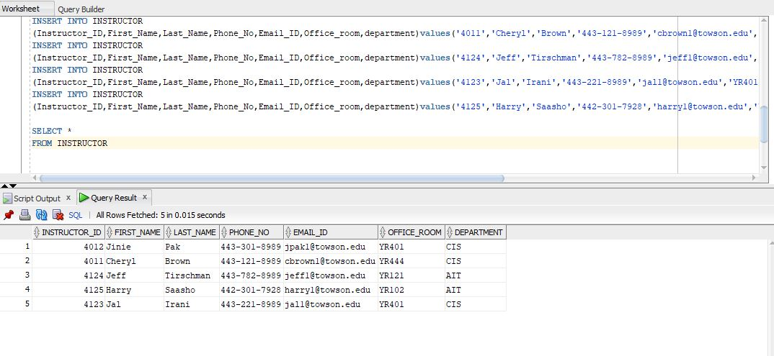

Enrollment table

Create query:

CREATE TABLE ENROLLMENT

(

Enrollment_ID int NOT NULL,

Student_ID int NOT NULL,

Course_ID int NOT NULL,

Payment_ID int NULL,

Instructor_ID int NOT NULL,

Status varchar(20) NOT NULL,

CONSTRAINT ENROLLMENT_pk PRIMARY KEY(Enrollment_ID),

CONSTRAINT Student_ID_fk FOREIGN KEY(Student_ID) REFERENCES STUDENT(Student_ID),

CONSTRAINT Course_ID_fk FOREIGN KEY(Course_ID) REFERENCES COURSE(Course_ID),

CONSTRAINT Instructor_ID_fk FOREIGN KEY(Instructor_ID) REFERENCES INSTRUCTOR(Instructor_ID)

);

-- query for adding foreign key constraint

ALTER TABLE ENROLLMENT

ADD CONSTRAINT ENROLLMENT_fk FOREIGN KEY (Payment_ID) REFERENCES PAYMENT (Payment_ID)

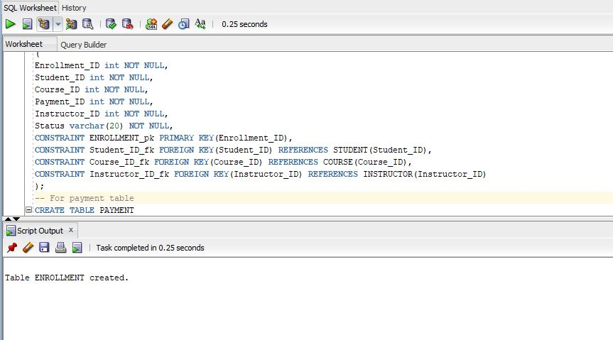

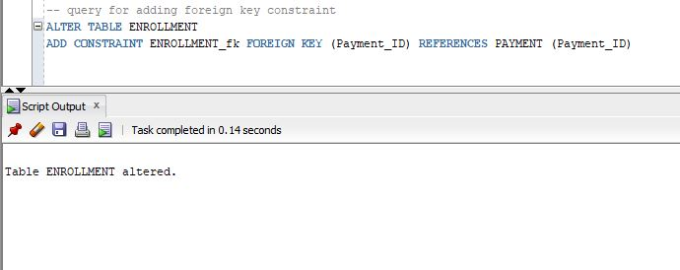

Insert Query:

INSERT INTO ENROLLMENT

(Enrollment_ID,Student_ID,Course_ID,Payment_ID,Instructor_ID,Status)values ('64023','680234','632','','4012','enrolled');

INSERT INTO ENROLLMENT

(Enrollment_ID,Student_ID,Course_ID,Payment_ID,Instructor_ID,Status)values ('64054','680132','624','','4011','withdrawn');

INSERT INTO ENROLLMENT

(Enrollment_ID,Student_ID,Course_ID,Payment_ID,Instructor_ID,Status)values ('64053','680232','732','','4011','enrolled');

INSERT INTO ENROLLMENT

(Enrollment_ID,Student_ID,Course_ID,Payment_ID,Instructor_ID,Status)values ('64076','680453','612','','4123','withdrawn');

INSERT INTO ENROLLMENT

(Enrollment_ID,Student_ID,Course_ID,Payment_ID,Instructor_ID,Status)values ('64075','680122','614','','4125','enrolled');

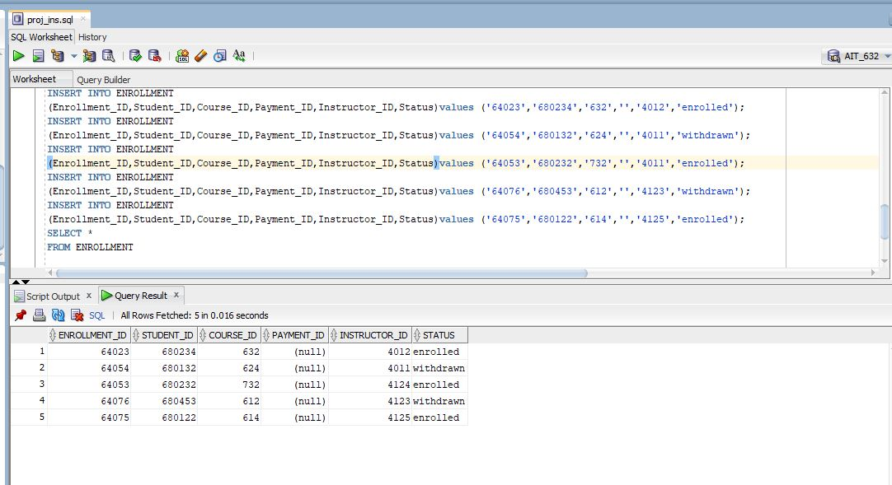

Note: Since the table enrollment has foreign key constrain on payment_ID. Null value has been inserted initially and updated with Payment_ID later when payment_ID has been created.

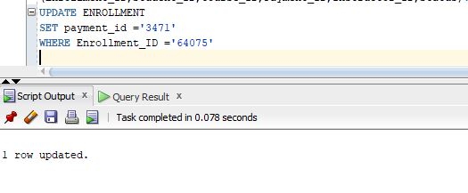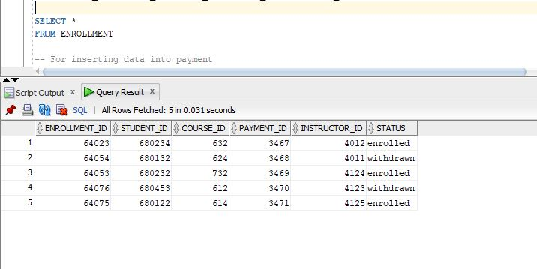

Payment table:

CREATE TABLE PAYMENT

(

Payment_ID int NOT NULL,

student_ID int NOT NULL,

Enrollment_ID int NOT NULL,

Account_Balance numeric(12,2) NOT NULL,

Payment_due numeric(12,2) NOT NULL,

Sem_year varchar(20) NOT NULL,

CONSTRAINT PAYMENT_pk PRIMARY KEY(Payment_ID),

CONSTRAINT Student_ID_fk1 FOREIGN KEY(Student_ID) REFERENCES STUDENT(Student_ID),

CONSTRAINT Enrollment_ID_fk2 FOREIGN KEY(Enrollment_ID) REFERENCES ENROLLMENT(Enrollment_ID)

);

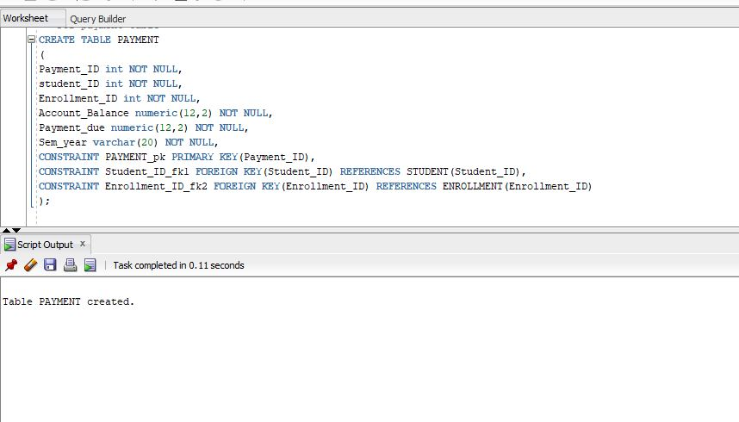

Insert payment:

INSERT INTO PAYMENT

(Payment_ID,Student_ID,enrollment_ID,account_balance,payment_due,sem_year)values('3467','680234','64023','234.80','100.80','Fall2018');

INSERT INTO PAYMENT

(Payment_ID,Student_ID,enrollment_ID,account_balance,payment_due,sem_year)values('3468','680132','64054','118.80','10.80','Spring2019');

INSERT INTO PAYMENT

(Payment_ID,Student_ID,enrollment_ID,account_balance,payment_due,sem_year)values('3469','680232','64053','134.80','11.80','Summer2018');

INSERT INTO PAYMENT

(Payment_ID,Student_ID,enrollment_ID,account_balance,payment_due,sem_year)values('3470','680453','64076','112.80','100.80','Fall2018');

INSERT INTO PAYMENT

(Payment_ID,Student_ID,enrollment_ID,account_balance,payment_due,sem_year)values('3471','680122','64075','100.80','1.80','Fall2019');

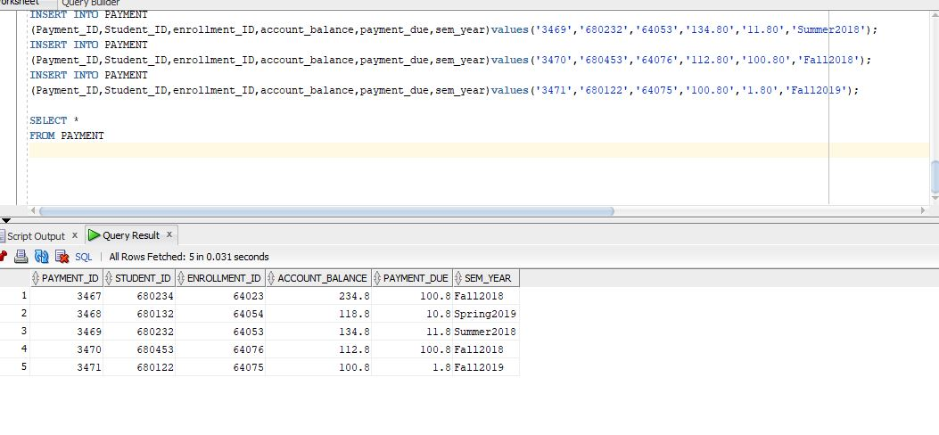

Grade table:

CREATE TABLE GRADE

(

Student_ID int NOT NULL,

Course_ID int NOT NULL,

Grade varchar(2) NOT NULL,

Credit int NOT NULL,

Status varchar(20) NOT NULL,

Sem_year varchar(20) NOT NULL,

CONSTRAINT Student_ID_fk2 FOREIGN KEY(Student_ID) REFERENCES STUDENT(Student_ID),

CONSTRAINT Course_ID_fk2 FOREIGN KEY(Course_ID) REFERENCES COURSE(Course_ID)

);

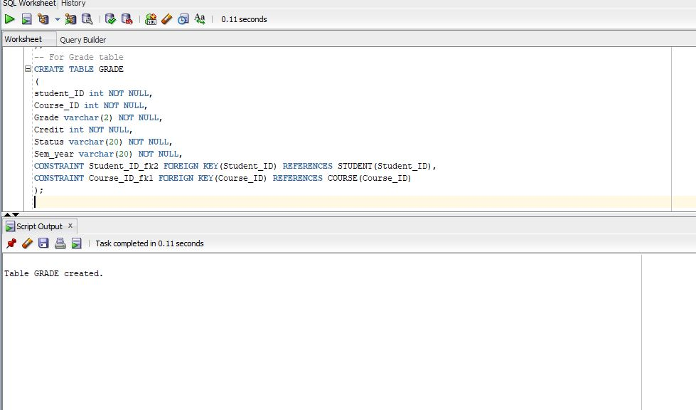

Insert Query:

INSERT INTO GRADE

(Student_ID,Course_ID,Grade,Credit,Status,Sem_year)VALUES ('680234','632','A-','3','Completed','Fall 2018');

INSERT INTO GRADE

(Student_ID,Course_ID,Grade,Credit,Status,Sem_year) VALUES('680132','624','B+','3','Completed','Spring 2018');

INSERT INTO GRADE

(Student_ID,Course_ID,Grade,Credit,Status,Sem_year) VALUES('680232','732','B-','3','Completed','Summer 2018');

INSERT INTO GRADE

(Student_ID,Course_ID,Grade,Credit,Status,Sem_year) VALUES('680453','612','FF','3','Fail','Spring 2018');

INSERT INTO GRADE

(Student_ID,Course_ID,Grade,Credit,Status,Sem_year) VALUES('680122','614','B+','3','Completed','Summer 2018');

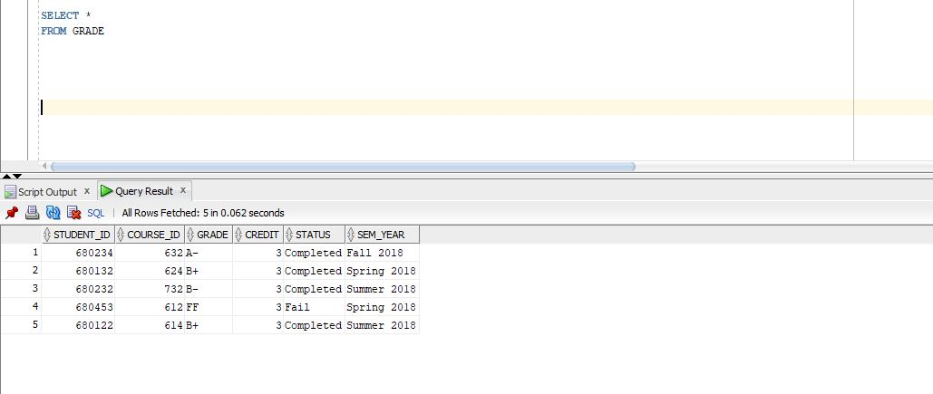

Real world Queries:

Question 1: What is the account balance and payment due of the students?

Solution: We use JOIN Command to find the result--

SELECT First_Name,Last_Name,payment_due,account_balance

FROM STUDENT

INNER JOIN PAYMENT ON PAYMENT.Student_ID = STUDENT.Student_ID

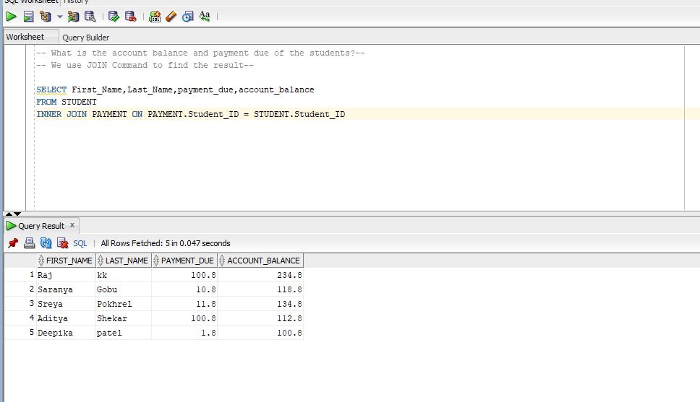

Question 2:

Show all the Email ID's of every person(Student and Instructor) associated with all Deprtments

Solution:

SELECT Email_ID

FROM INSTRUCTOR

UNION

SELECT Email_ID

FROM STUDENT

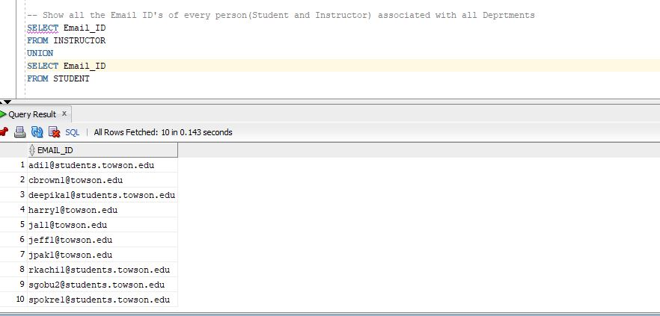

Question 3: How many instructors are present in each department?

Solution:

SELECT department,COUNT(Instructor_ID) as "number of instructors"

FROM INSTRUCTOR

GROUP BY Department

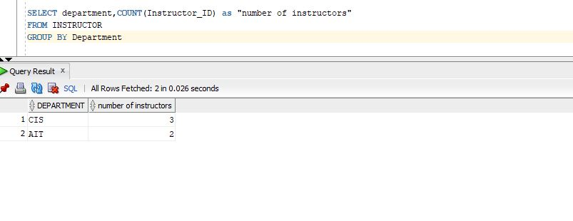

Question 4: Show all the STUDENT_ID who have withdrawn the courses?

Solution:

SELECT STUDENT_ID

FROM STUDENT

INTERSECT

SELECT STUDENT_ID

FROM ENROLLMENT

WHERE STATUS = ’withdrawn’

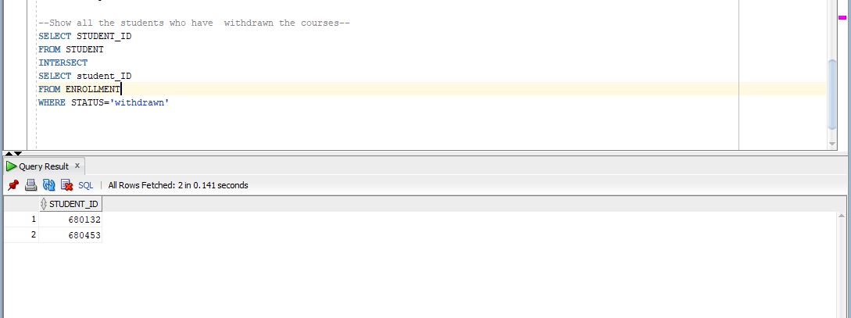

Question 5: What courses are offered during SUMMER 2019?

Solution:

SELECT COURSE_NAME

FROM COURSE

WHERE SEMESTER_OFFERED='Summer 2019'

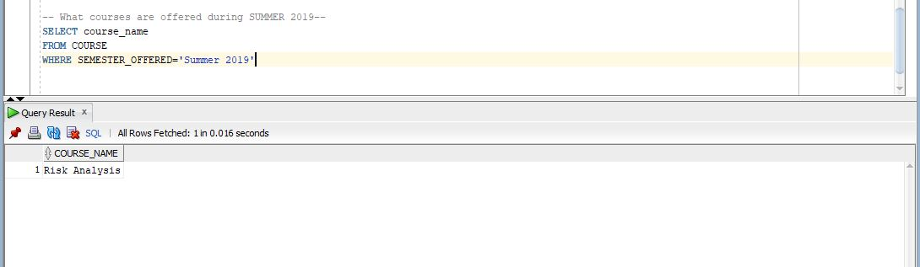

Question 6: Show the student who has the maximum account balance?

Solution:

SELECT FIRST_NAME,LAST_NAME

FROM STUDENT

WHERE STUDENT_ID=

(SELECT STUDENT_ID

FROM PAYMENT

WHERE ACCOUNT_BALANCE = (SELECT MAX(ACCOUNT_BALANCE)FROM PAYMENT));

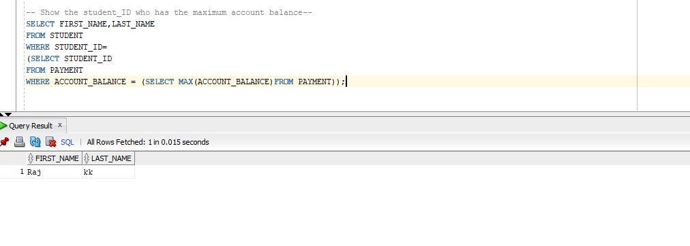

Question 7: Display all the student's account balance after their payment due is being made

Solution:

SELECT first_name, last_name, ACCOUNT_BALANCE-PAYMENT_DUE AS "ACCOUNT BALANCE"

FROM PAYMENT

INNER JOIN STUDENT ON STUDENT.STUDENT_ID = PAYMENT.STUDENT_ID

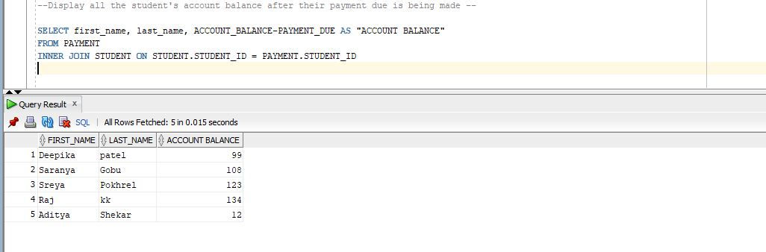

Question 8: Update last name of the instructor whose instructor_ID is 4011.

Solution:

UPDATE INSTRUCTOR

SET LAST_NAME='kk'

WHERE INSTRUCTOR_ID ='4011';

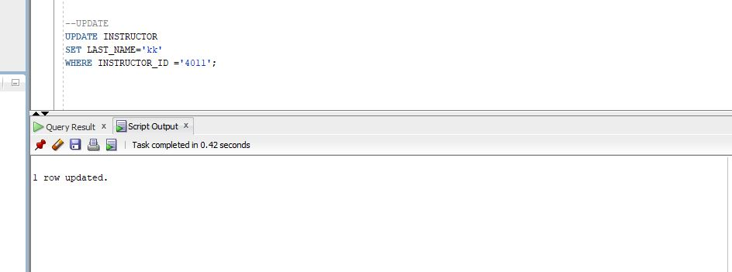

Question 9:Display the last names of the student's which are distinct from instructor's last name--

Solution:

SELECT LAST_NAME

FROM STUDENT

MINUS

SELECT LAST_NAME

FROM INSTRUCTOR

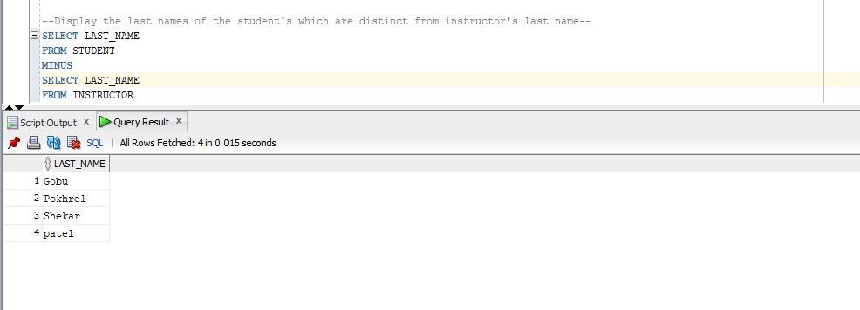

Question 10: --Display all the Instructor's who belong to AIT department

Solution:

SELECT first_name,last_name

FROM INSTRUCTOR

WHERE DEPARTMENT=’AIT’

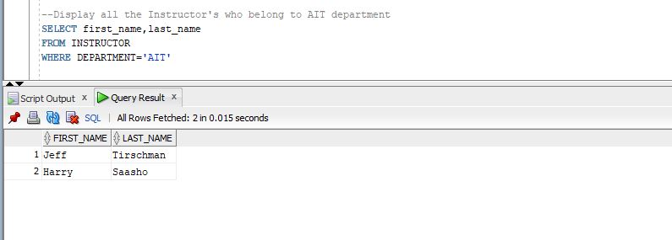

Question 12: List all the names and IDs of students who have a B grade.

Solution:

SELECT FIRST_NAME, LAST_NAME, GRADE.STUDENT_ID

FROM STUDENT, GRADE

WHERE GRADE.STUDENT_ID=STUDENT.STUDENT_ID

AND GRADE LIKE '%B%';

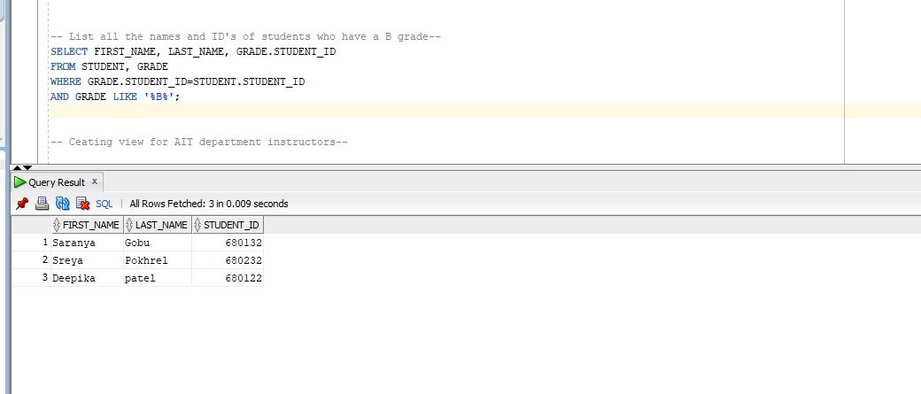

Question 11: List the instructor(s) situated in office_room YR102 in AIT department

Solution:

SELECT FIRST_NAME, LAST_NAME

FROM INSTRUCTOR

WHERE OFFICE_ROOM = 'YR102'

AND DEPARTMENT='AIT'

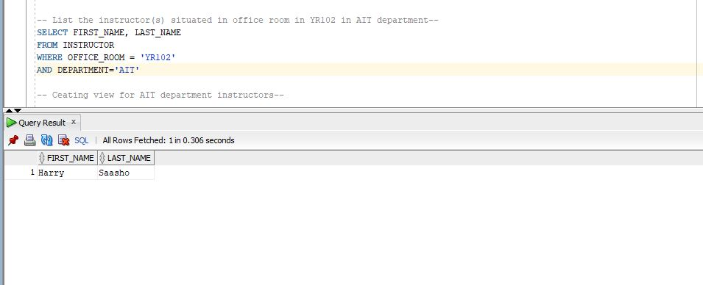

Creating view for AIT department instructors

CREATE VIEW AIT_department_instructors AS

SELECT first_name,last_name

FROM INSTRUCTOR

WHERE DEPARTMENT='AIT'

SELECT *

FROM AIT_department_instructors

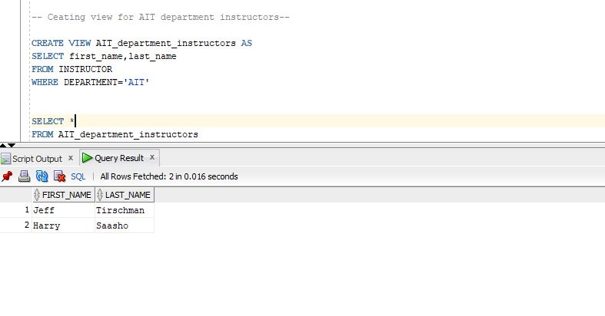

Creating view for students who have withdrawn courses

CREATE VIEW withdrawn_students AS

SELECT STUDENT_ID

FROM STUDENT

INTERSECT

SELECT student_ID

FROM ENROLLMENT

WHERE STATUS='withdrawn'

SELECT *

FROM withdrawn_students

